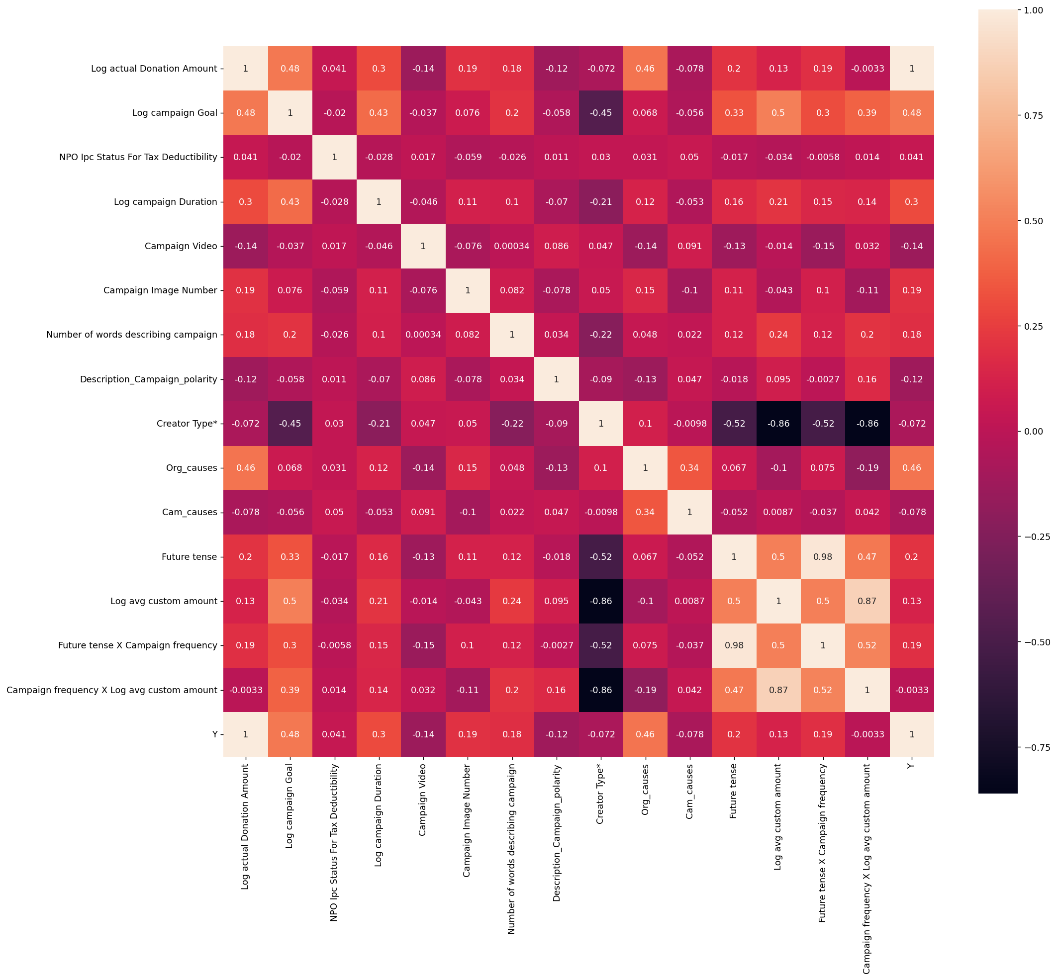

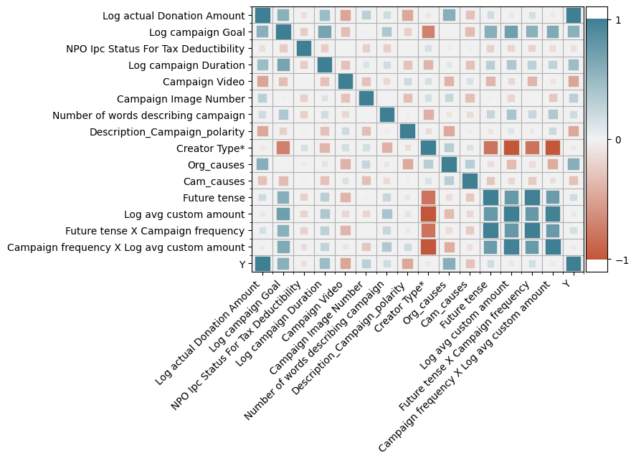

New Model

Table1 correlation Matrix and descriptive statistics

|  |  |  |  |  |  |  |  |  |  |  |  |  |  |  |  |  |  |  |  |  |
| --- | --- | --- | --- | --- | --- | --- | --- | --- | --- | --- | --- | --- | --- | --- | --- | --- | --- | --- | --- | --- |
|  |  | Mean | Std.Dev | Min | Max | [1] | [2] | [3] | [4] | [5] | [6] | [7] | [8] | [9] | [10] | [11] | [12] | [13] | [14] | [15] |
| [1] | DV:Log donation Amount | 6.36 | 3.33 | 0 | 15.05 | 1 |  |  |  |  |  |  |  |  |  |  |  |  |  |  |
| [2] | Log campaign Goal | 8.93 | 1.89 | 4.61 | 15.42 | 0.48 | 1 |  |  |  |  |  |  |  |  |  |  |  |  |  |
| [3] | Tax Deductibility | 0.93 | 0.24 | 0 | 1 | 0.041 | -0.02 | 1 |  |  |  |  |  |  |  |  |  |  |  |  |
| [4] | Log Campaign Duration | 4.21 | 1.02 | 0.69 | 6.45 | 0.3 | 0.43 | -0.028 | 1 |  |  |  |  |  |  |  |  |  |  |  |
| [5] | Campaign Video | 0.404 | 0.49 | 0 | 1 | -0.14 | -0.037 | 0.017 | -0.046 | 1 |  |  |  |  |  |  |  |  |  |  |
| [6] | Number of images | 2.87 | 1.59 | 0 | 5 | 0.19 | 0.076 | -0.059 | 0.11 | -0.076 | 1 |  |  |  |  |  |  |  |  |  |
| [7] | Words of campaign | 138 | 67 | 1 | 309 | 0.18 | 0.2 | -0.026 | 0.1 | 0.0003 | 0.082 | 1 |  |  |  |  |  |  |  |  |
| [8] | Campaign Polarity | 0.166 | 0.155 | -0.78 | 1 | -0.12 | -0.058 | 0.011 | -0.07 | 0.086 | -0.078 | 0.034 | 1 |  |  |  |  |  |  |  |
| [9] | Creator Type | 0.622 | 0.96 | 0 | 7 | -0.072 | -0.45 | 0.03 | -0.21 | 0.047 | 0.05 | -0.22 | -0.09 | 1 |  |  |  |  |  |  |
| [10] | Start_Year | 2020 | 1.4 | 2017 | 2022 | -0.17 | -0.073 | 0.029 | -0.076 | 0.11 | -0.18 | -0.074 | 0.085 | -0.005 | 1 |  |  |  |  |  |
| [11] | Organization Causes | 2.99 | 1.53 | 0 | 4 | 0.46 | 0.068 | 0.031 | 0.12 | -0.14 | 0.15 | 0.15 | -0.13 | 0.1 | -0.14 | 1 |  |  |  |  |
| [12] | Campaign Causes | 3.5 | 0.92 | 1 | 4 | -0.08 | -0.056 | 0.05 | -0.053 | 0.091 | -0.1 | -0.1 | 0.047 | -0.01 | 0.18 | 0.34 | 1 |  |  |  |
| [13] | Future tense | 0.89 | 1.76 | 0 | 10 | 0.2 | 0.33 | -0.017 | 0.16 | -0.13 | 0.11 | 0.11 | -0.018 | -0.52 | -0.073 | 0.067 | -0.052 | 1 |  |  |
| [14] | Log avg custom amount | 2.57 | 2.53 | 0 | 13.71 | 0.13 | 0.5 | -0.034 | 0.21 | -0.014 | 0.043 | -0.043 | 0.095 | -0.86 | 0.56 | -0.1 | 0.0087 | 0.5 | 1 |  |
| [15] | Future tense X Campaign frequency | 13.08 | 63.79 | 0 | 535 | 0.19 | 0.3 | -0.006 | 0.15 | -0.15 | 0.1 | 0.1 | -0.0027 | -0.52 | -0.071 | 0.075 | -0.037 | 0.98 | 0.5 | 1 |
| [16] | Campaign frequency X Log avg custom amount | 307.6 | 1088.35 | 0 | 4579.5 | -0.003 | 0.39 | 0.014 | 0.14 | 0.032 | -0.11 | -0.11 | 0.16 | -0.86 | 0.12 | -0.19 | 0.042 | 0.47 | 0.87 | 0.52 |

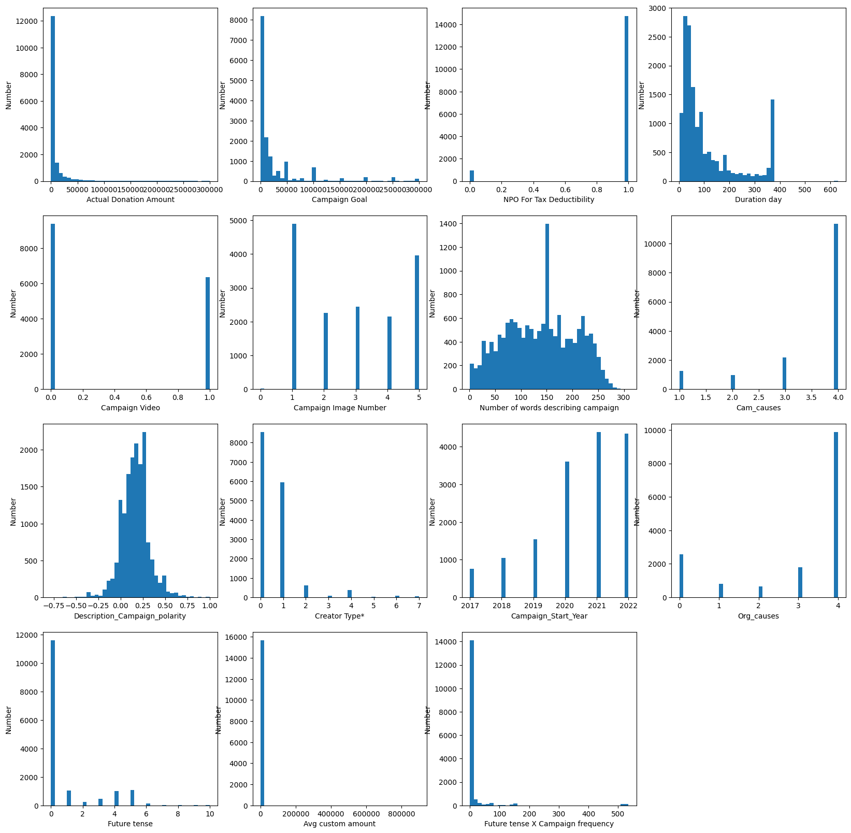

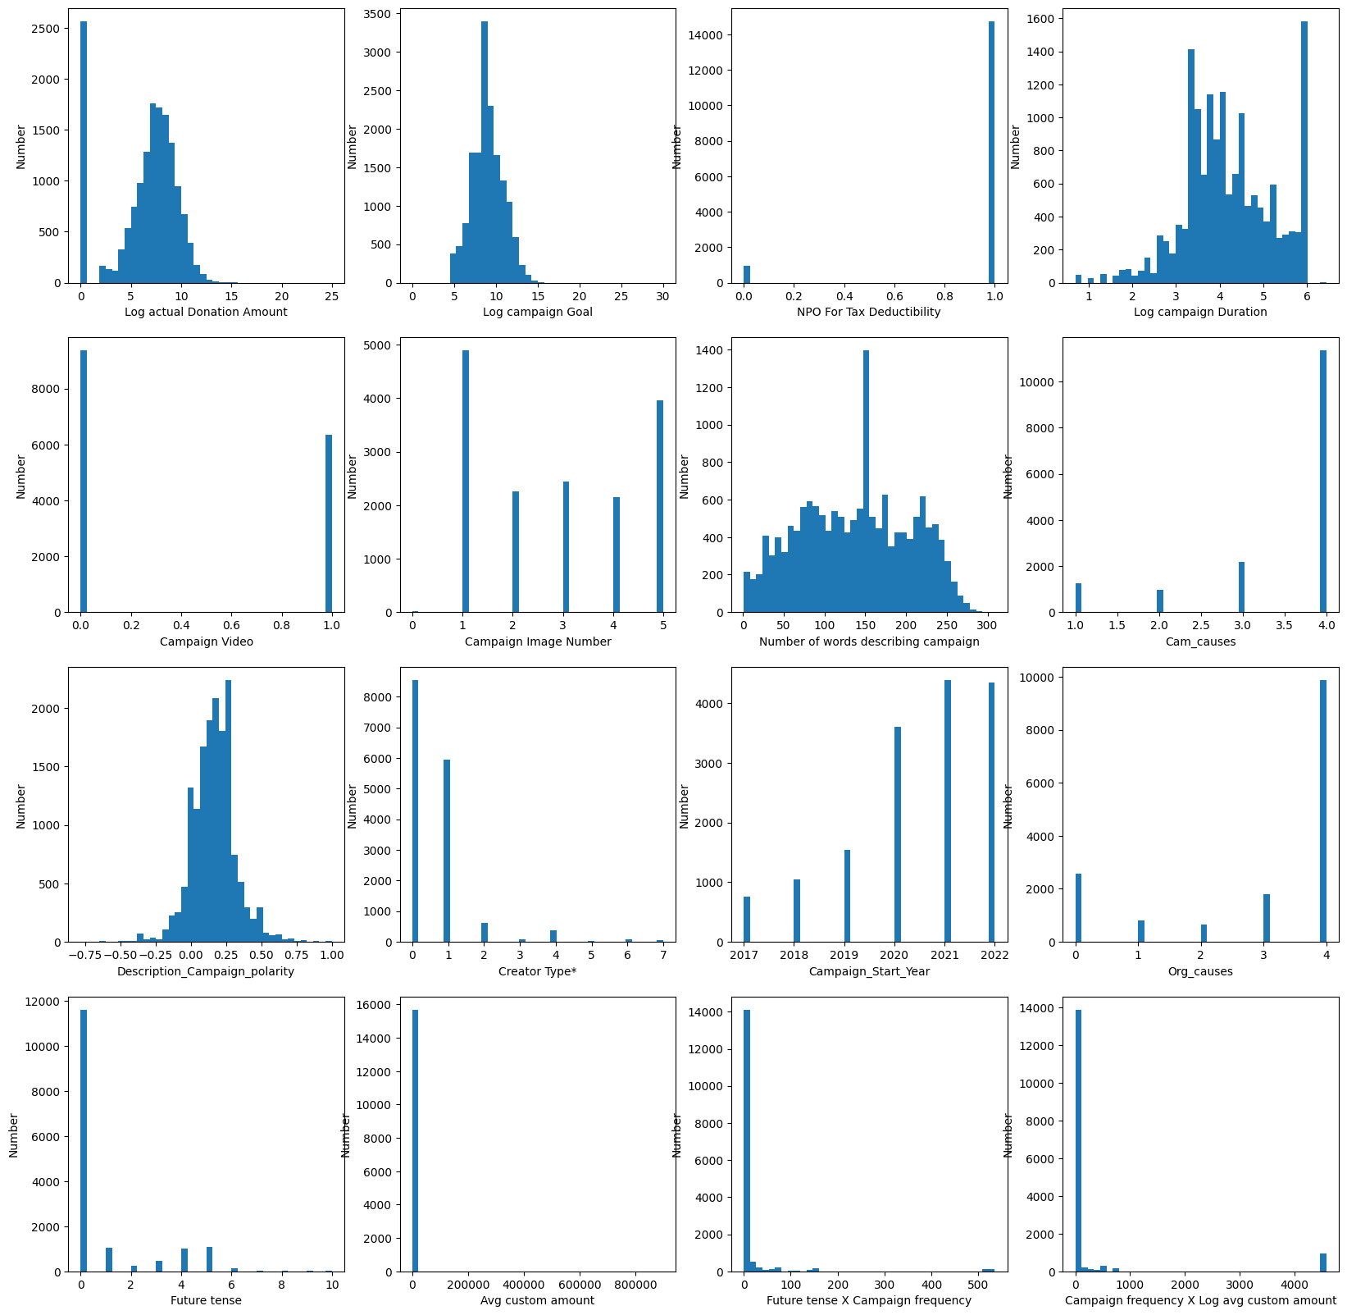

**VIF Test**

The new regression result.

Log actual Donation Amount 14.952254

Log campaign Goal 44.279120

NPO Ipc Status For Tax Deductibility 17.093713

Log campaign Duration 22.951148

Campaign Video 1.916691

Campaign Image Number 4.867730

Number of words describing campaign 5.881450

Description_Campaign_polarity 2.262649

Creator Type* 2.546407

Campaign_Start_Year 74.662325

Org_causes 14.506788

Cam_causes 20.418762

Future tense 1.973887

Log avg custom amount 5.724835

Future tense X Campaign frequency 1.303243

Campaign frequency X Log avg custom amount 2.032814

**Normality test without BOX-COX transformation**

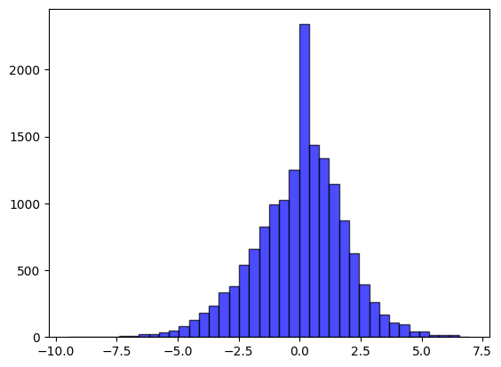

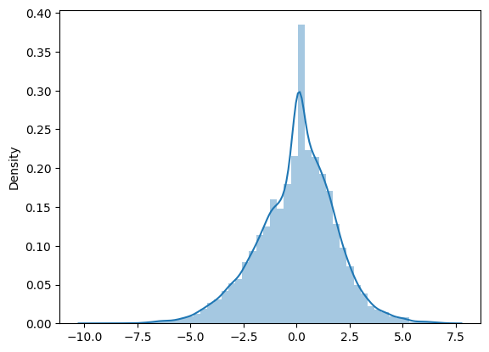

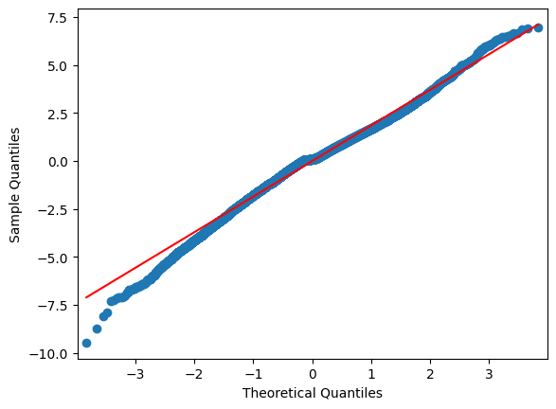

Result based on original data set:

Model 1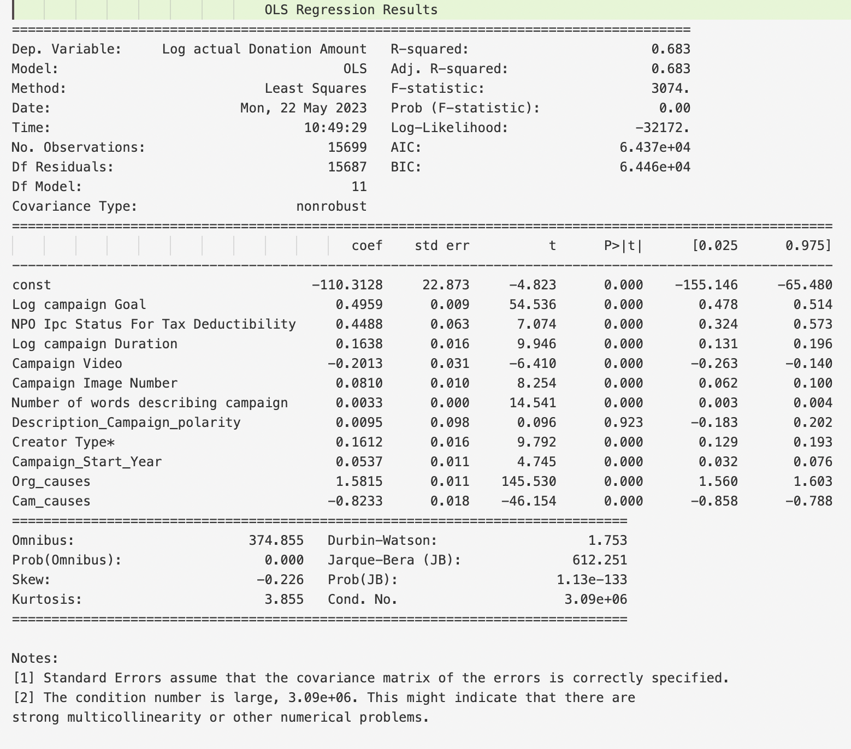

Model 2

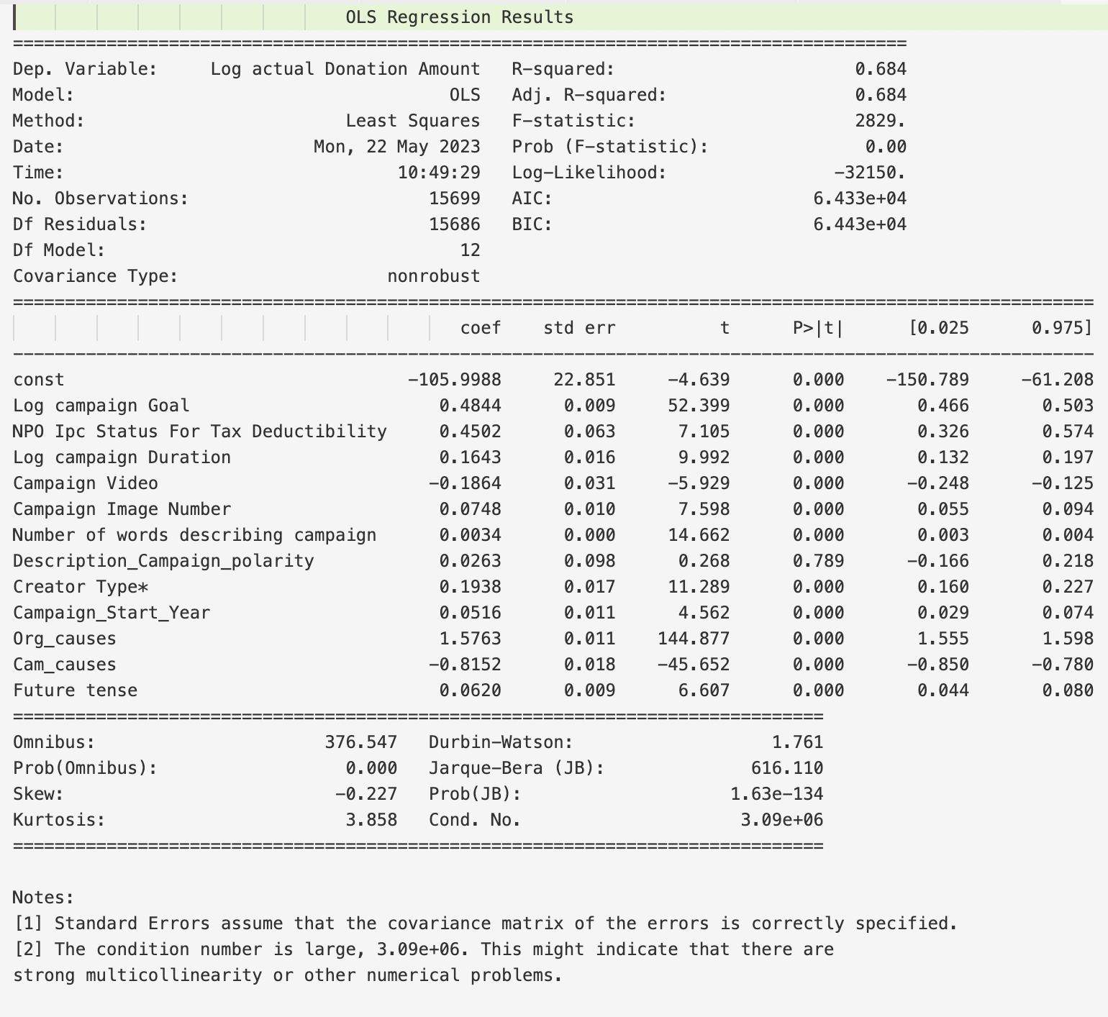

Model 3

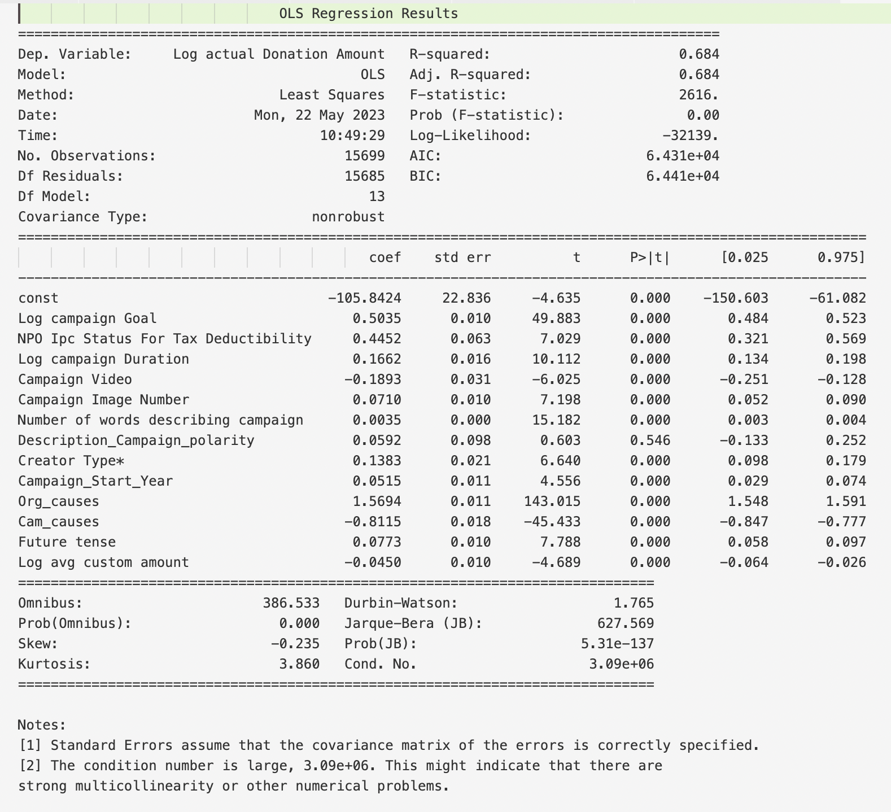

Model 4

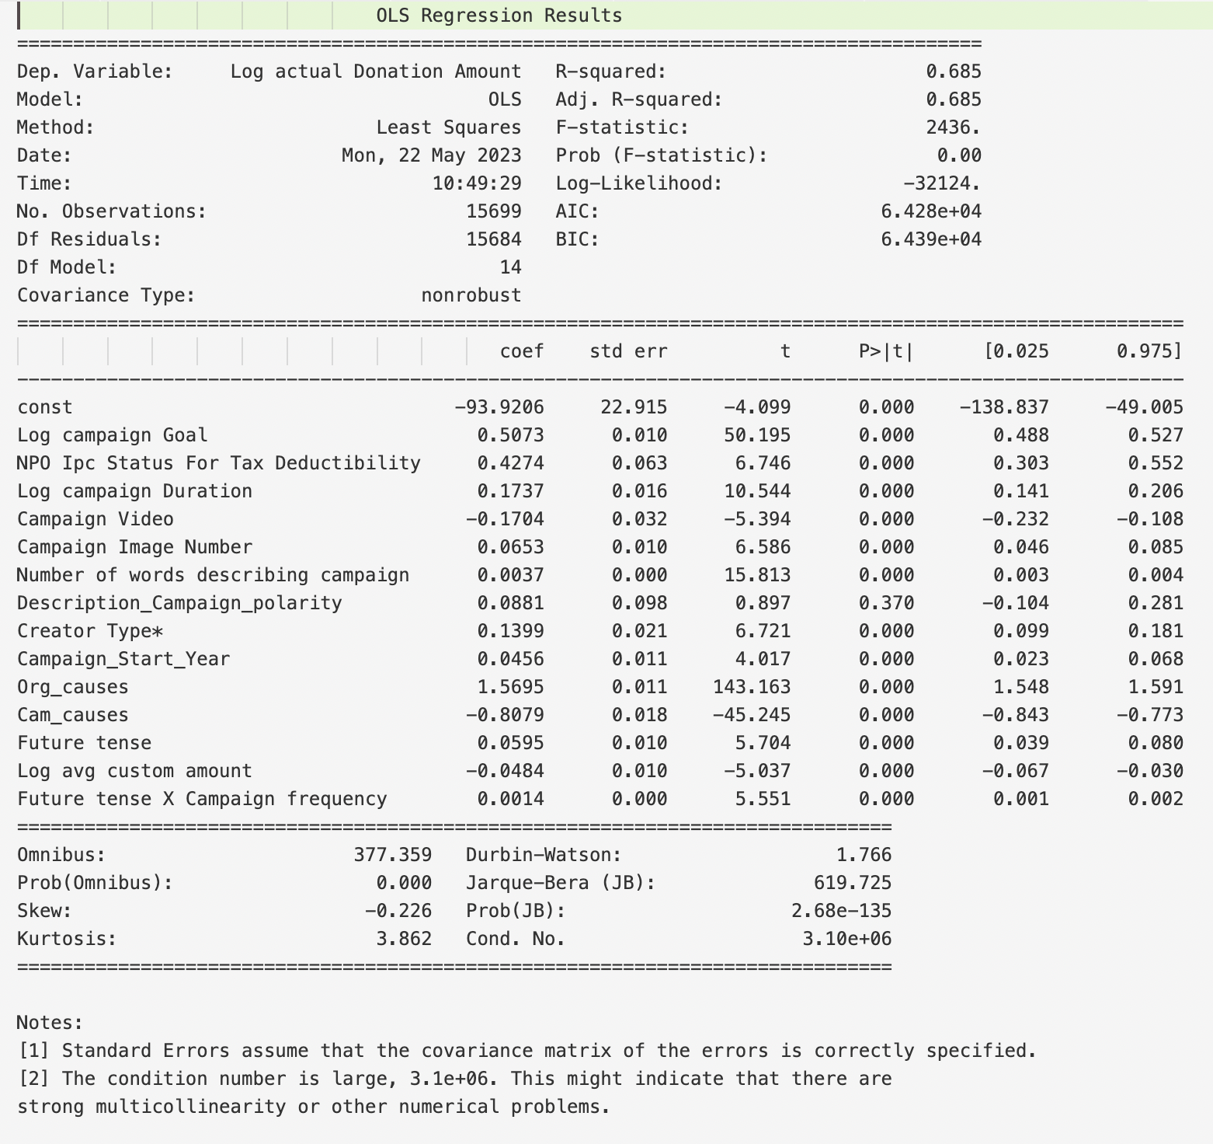

Model 5-1

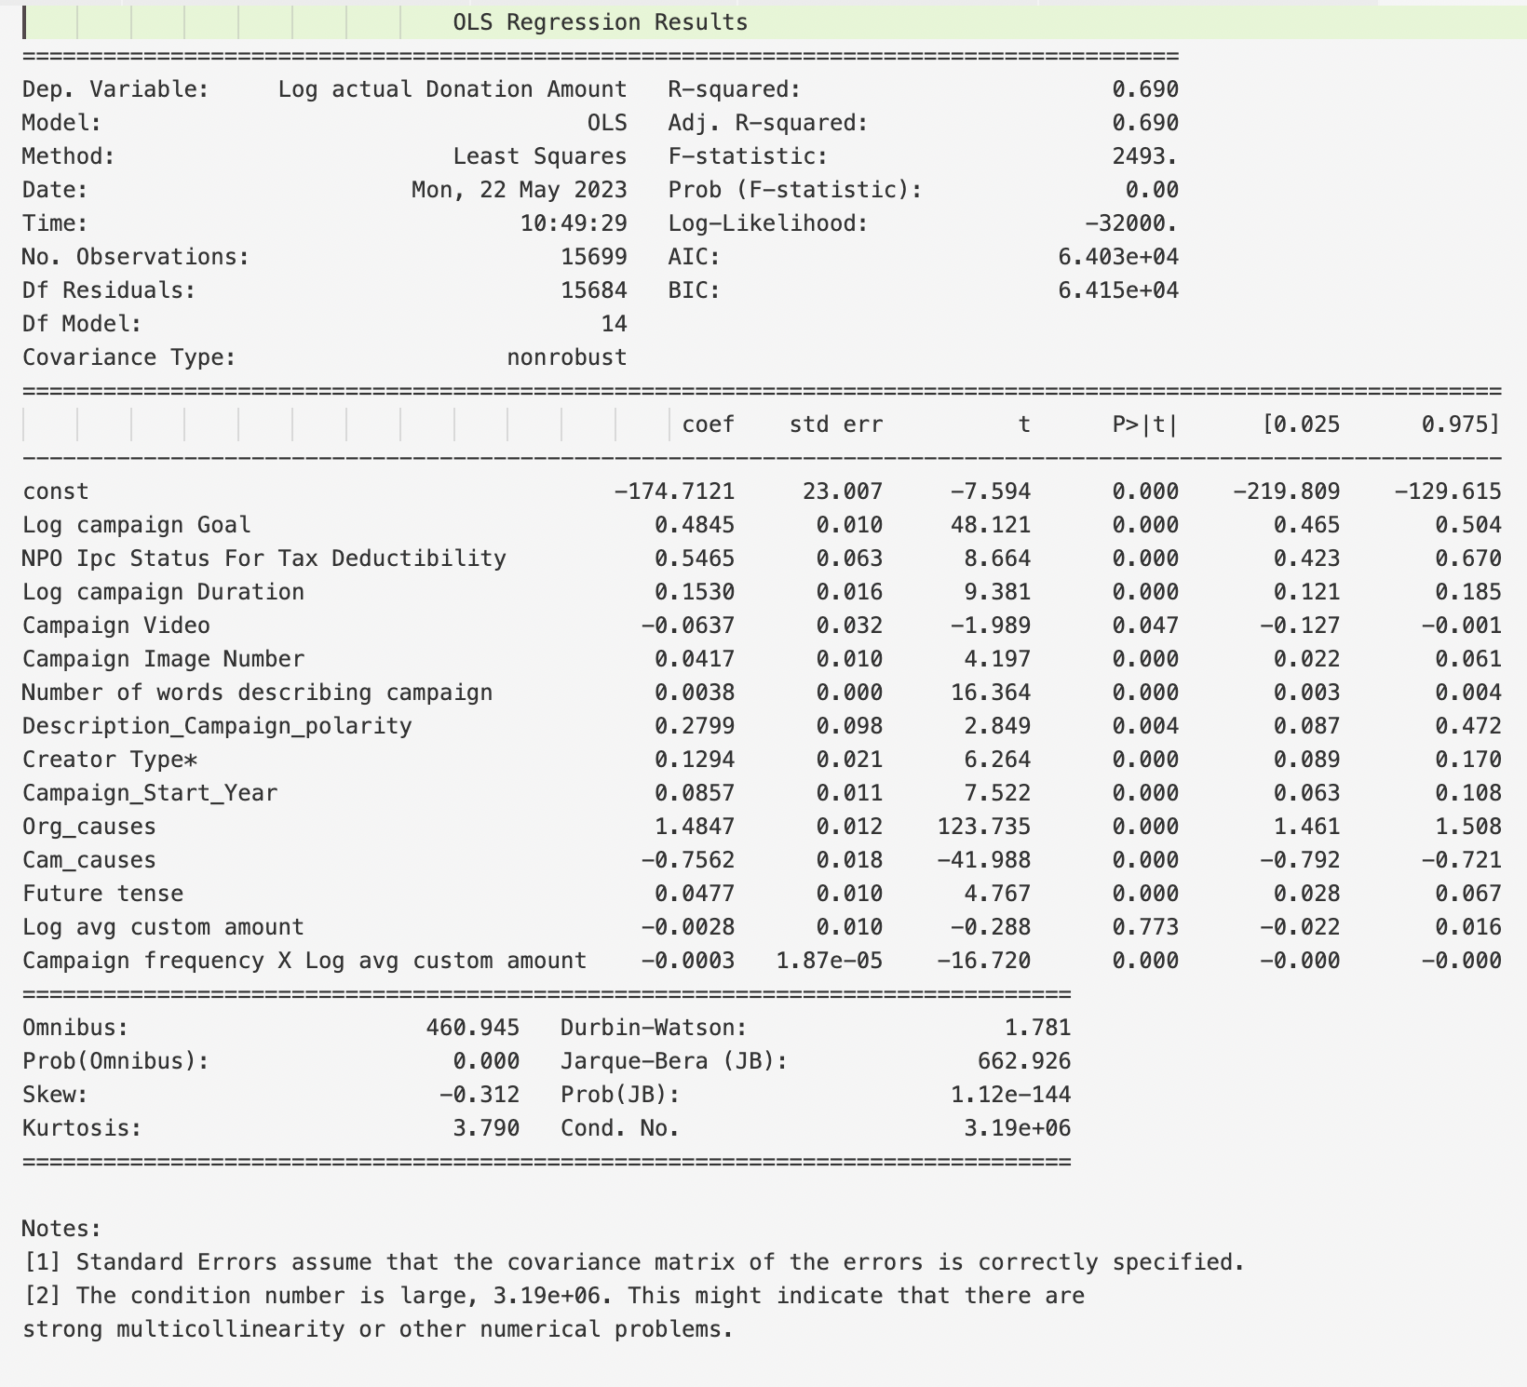

Model 5-2

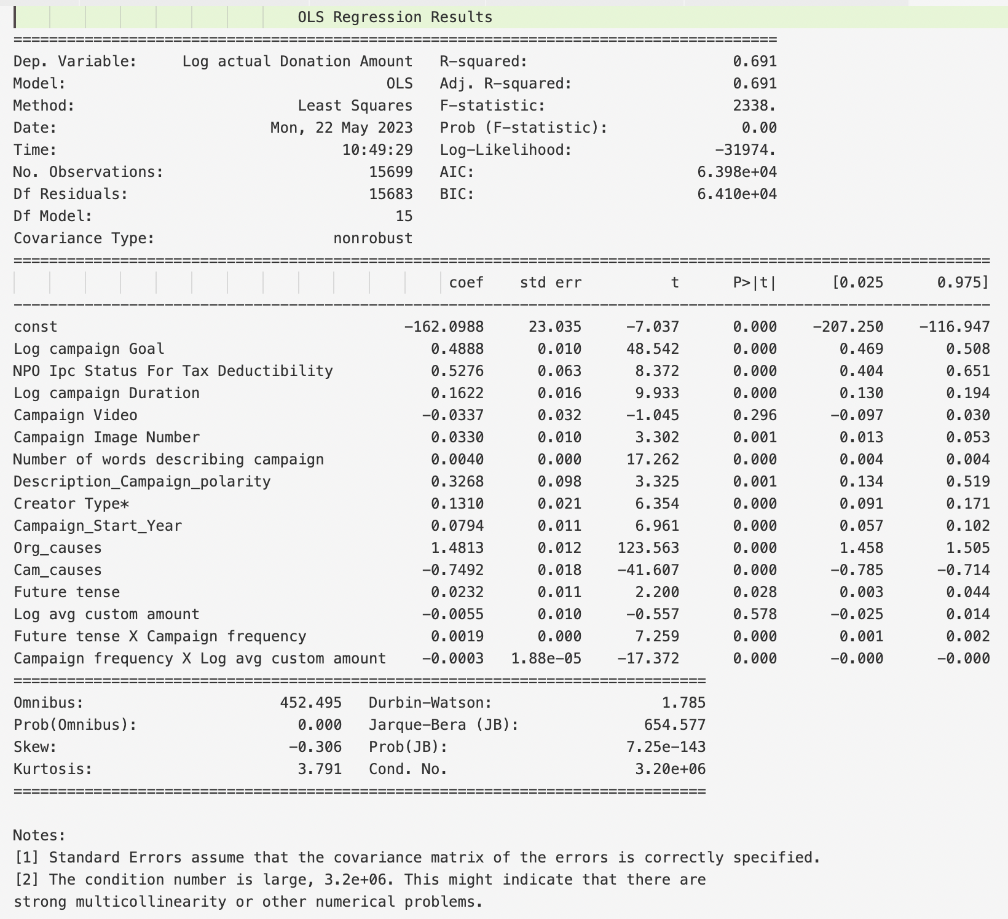

Robust test Model 6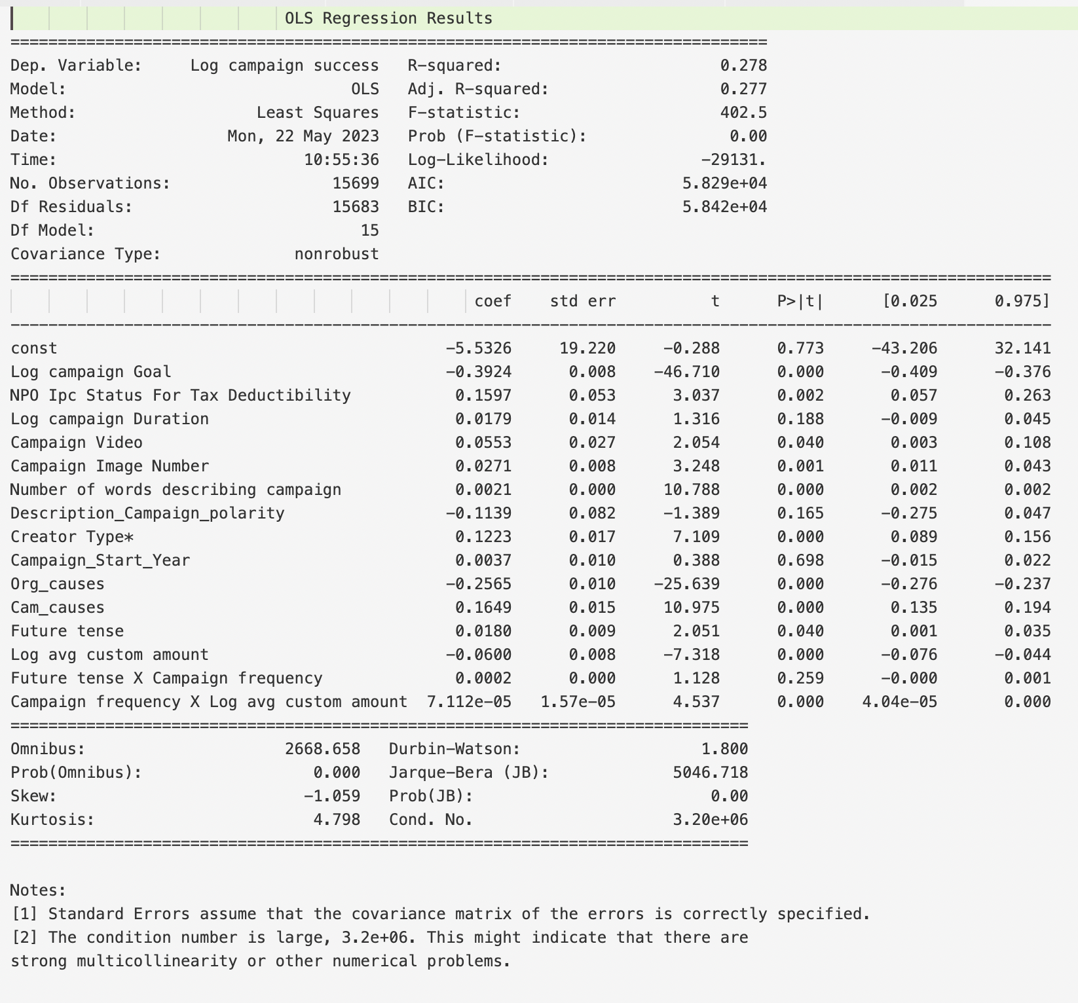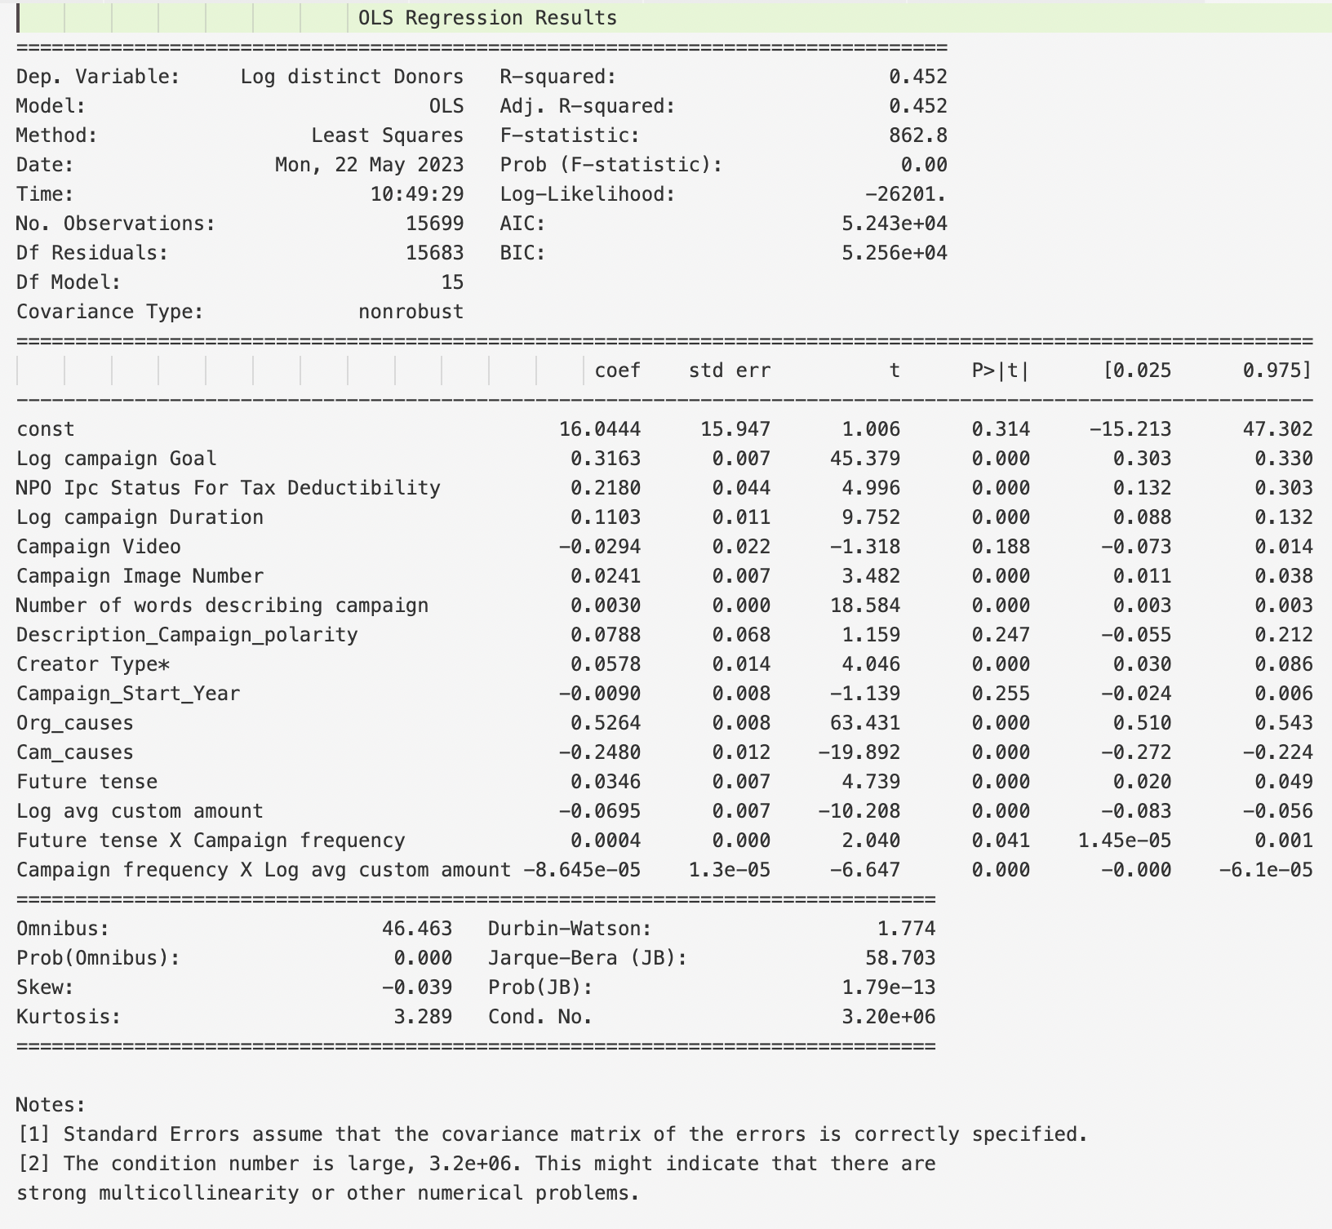

Test on New data sets(after part 1 2 3 operatio)

The result even better !

Model 1

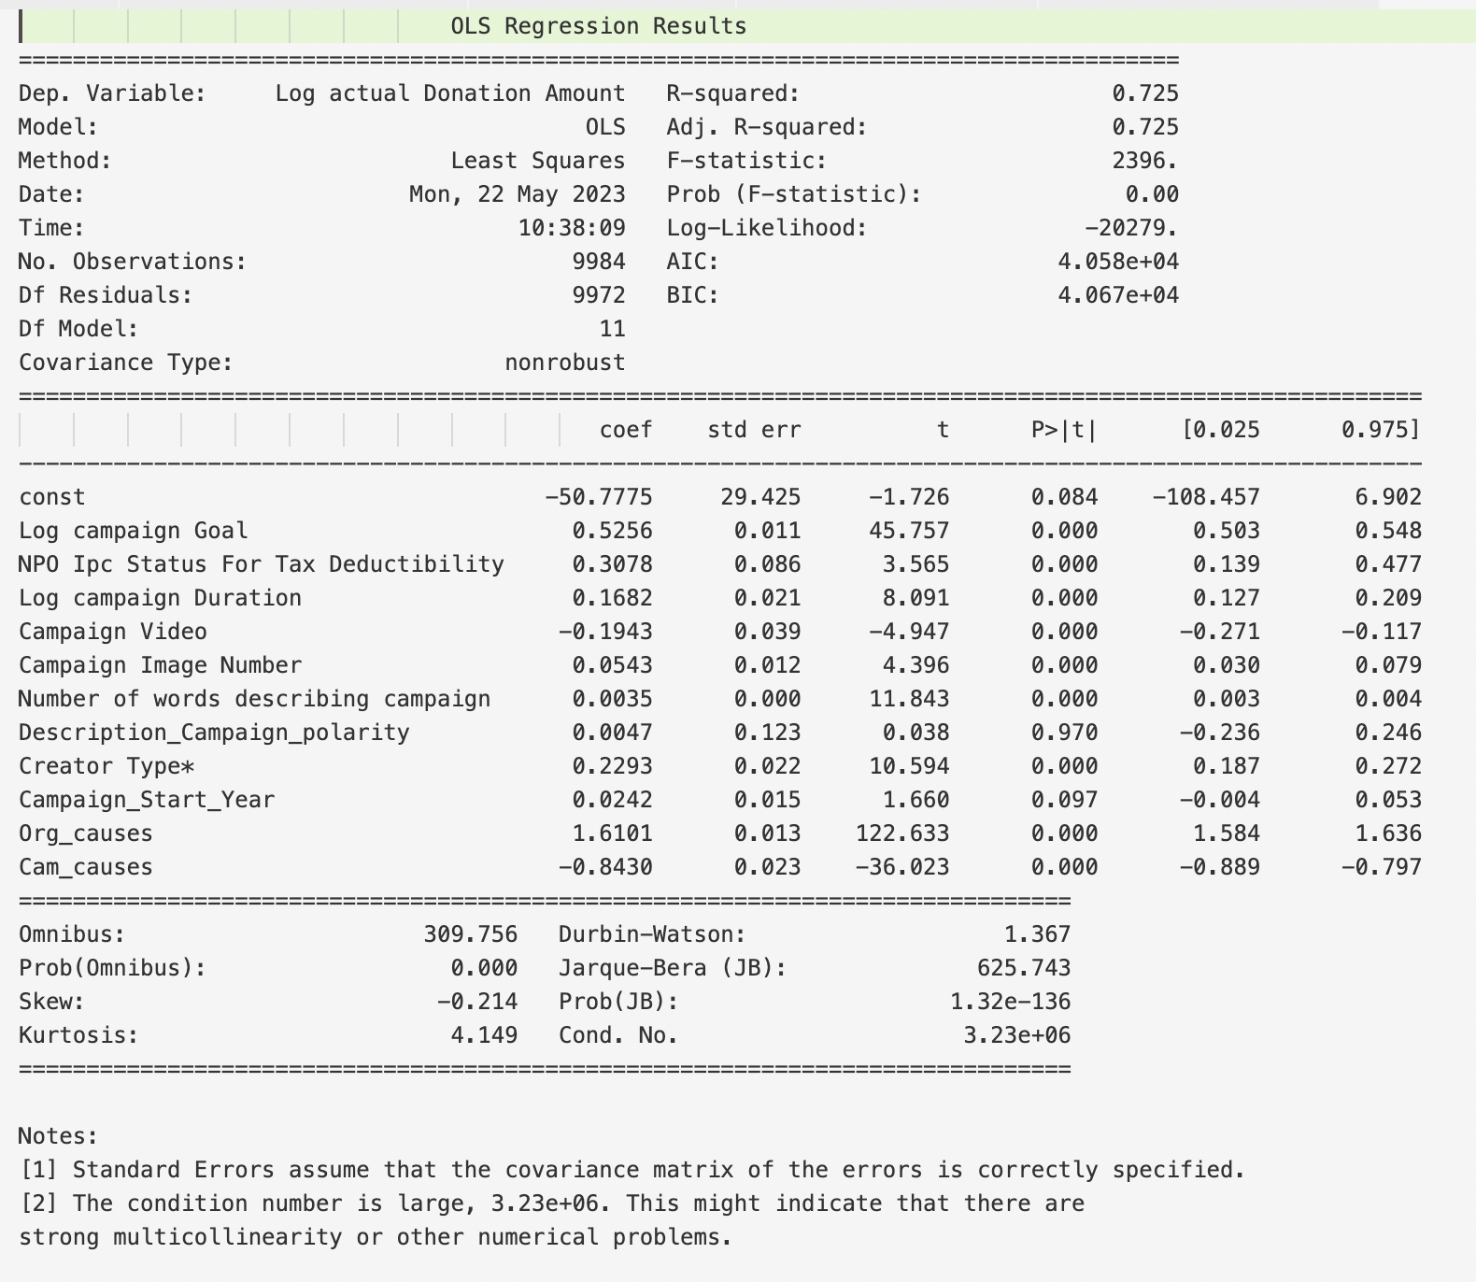

Model 2

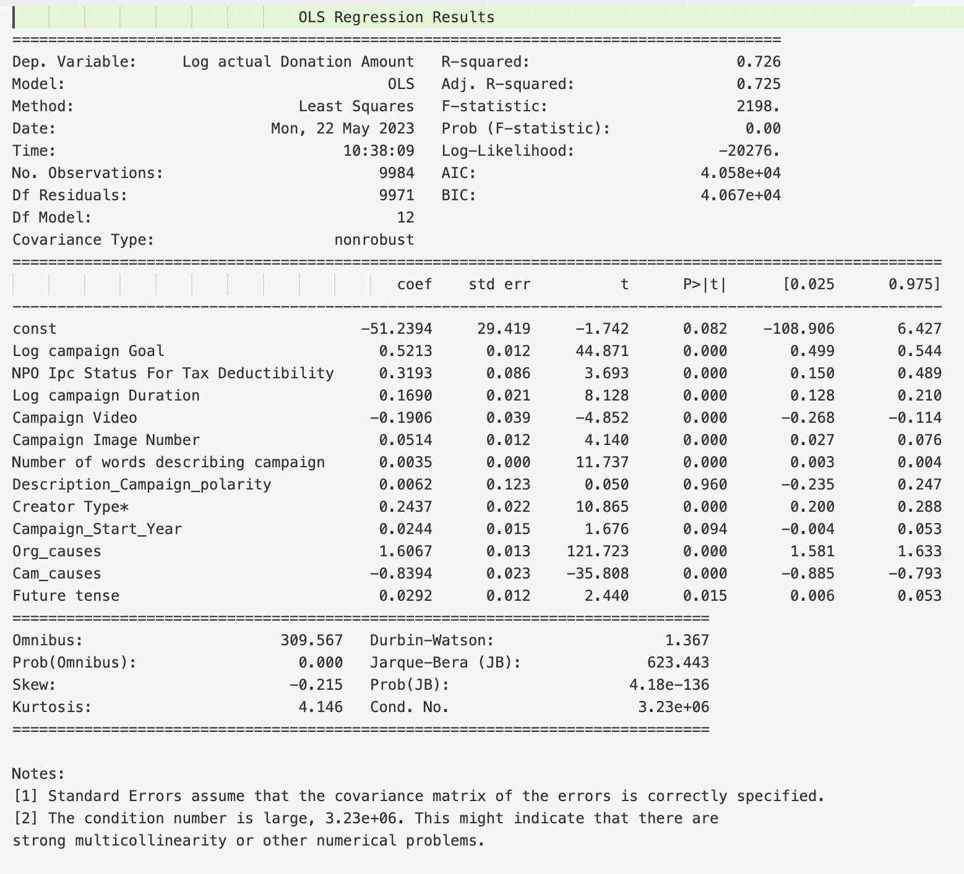

Model 3

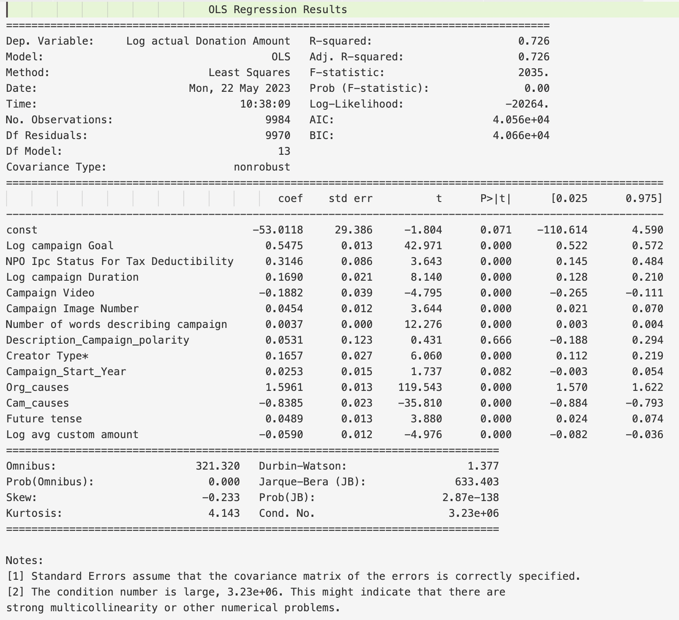

Model 4

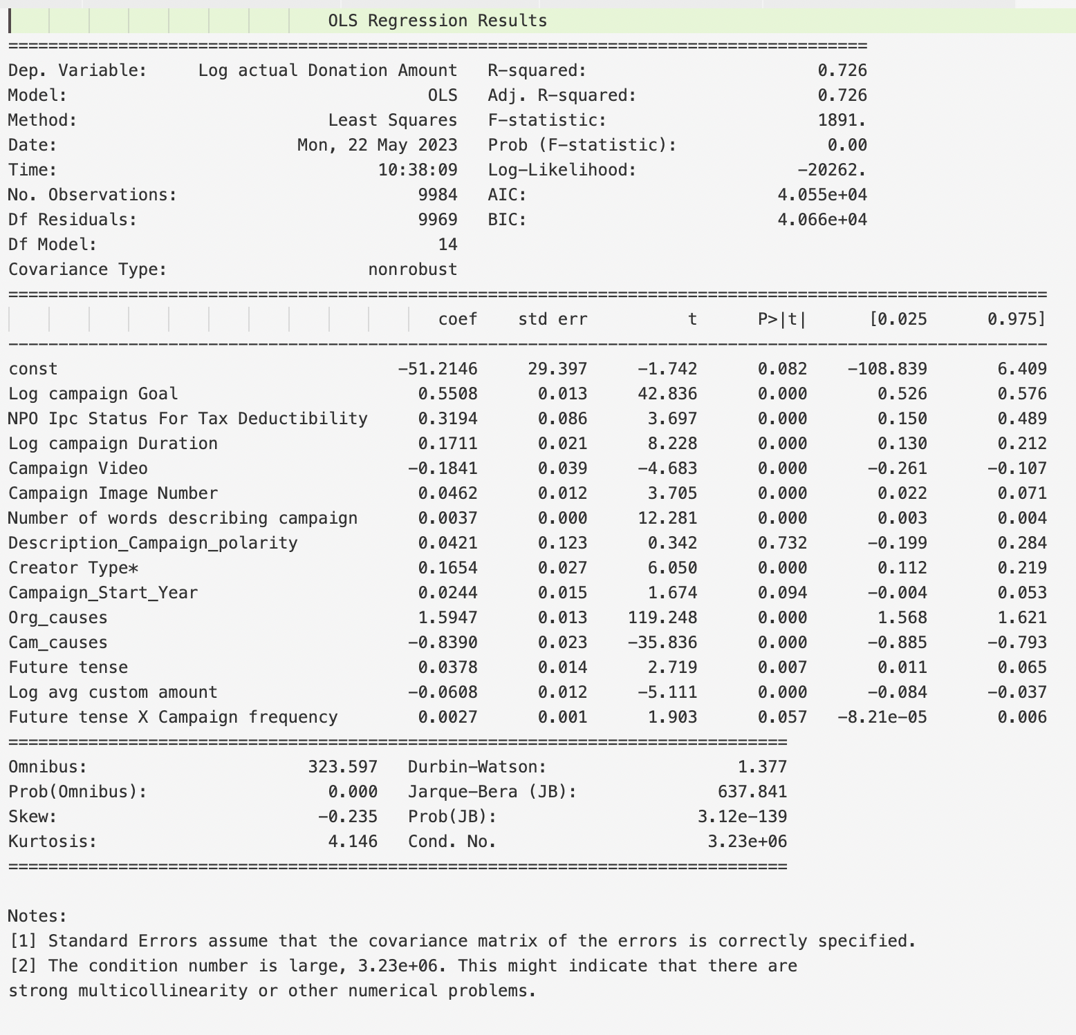

Model 5-1

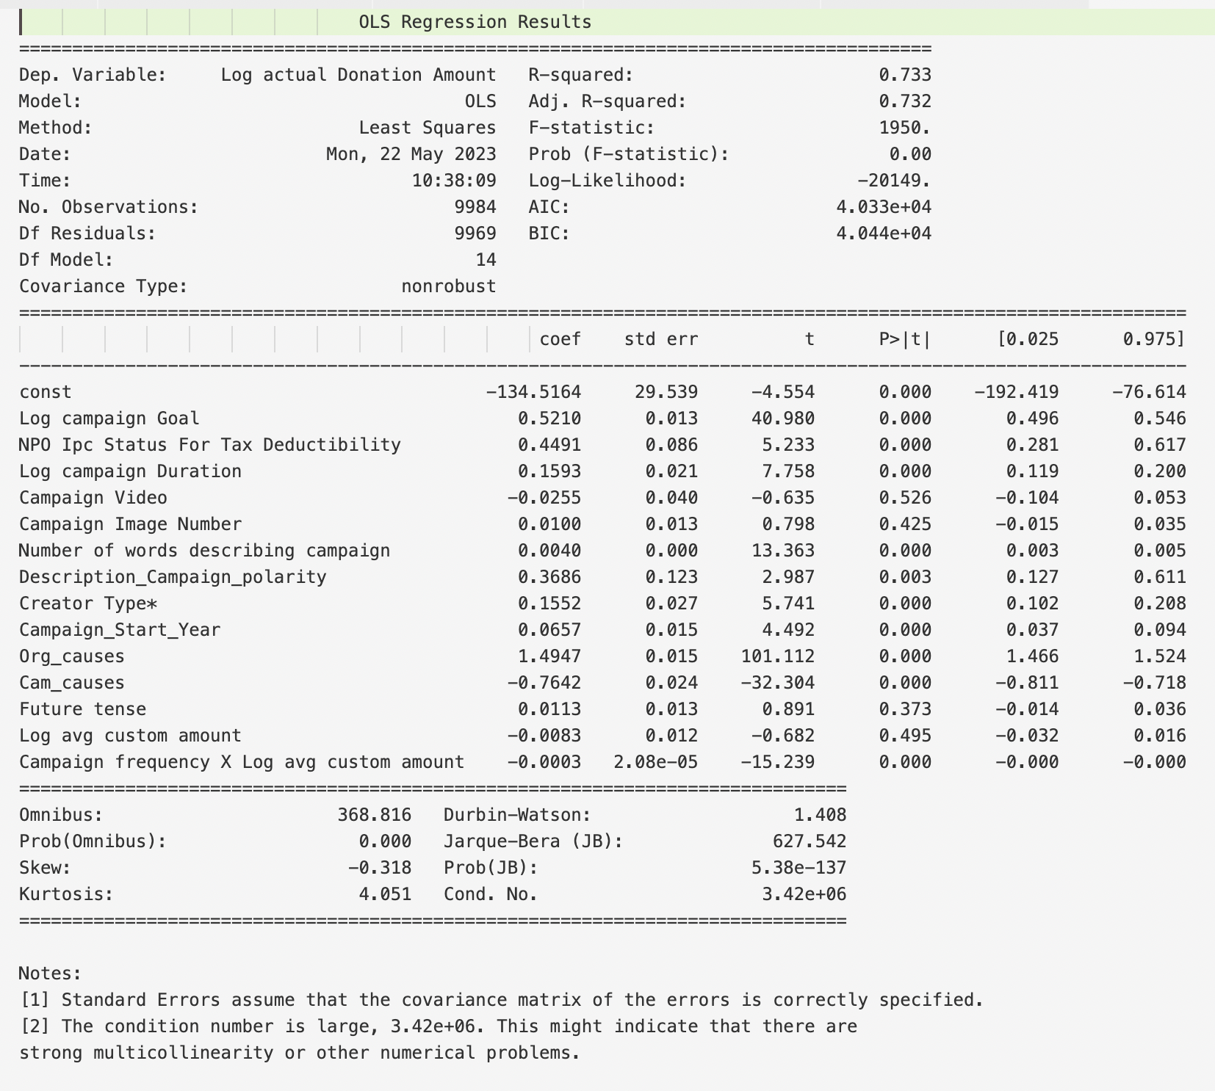

Model 5-2

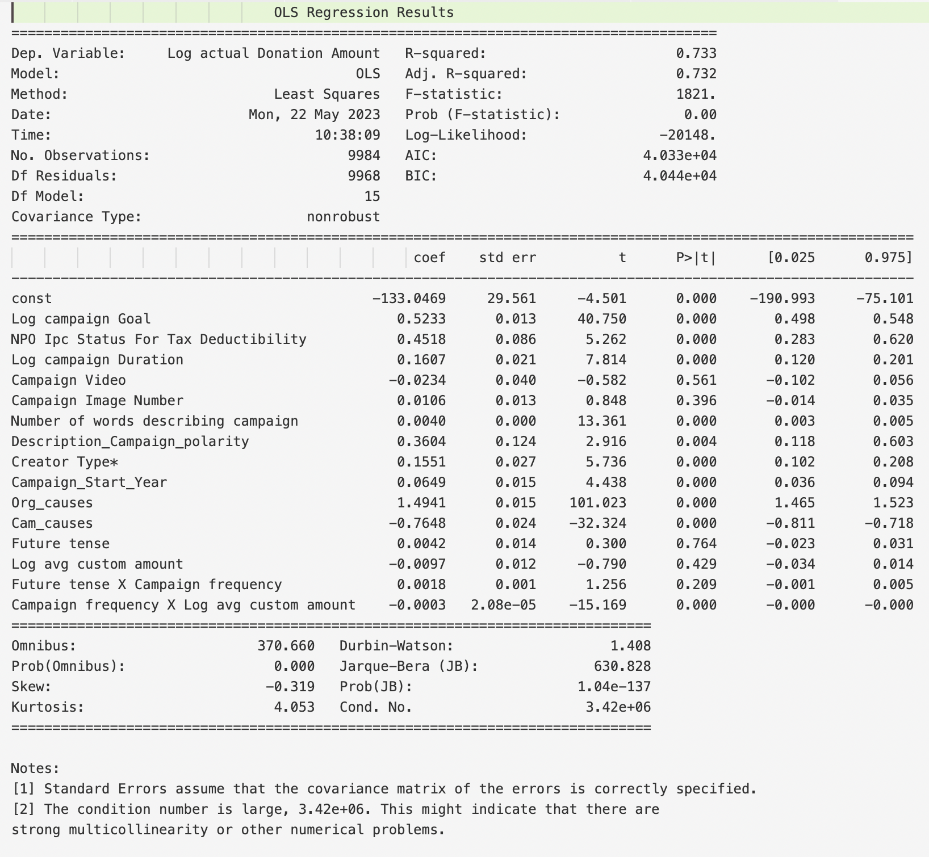

Robust test: Model 6

